ONLINE VEHICLE PARKING RESERVATION SYSTEM
Design and Implementation
Department of Computer Science and Engineering, TKR College of Engineering & Technology
Batch C3 (CSE-C) · Academic year [ACADEMIC YEAR]
Table 1: Project team
S.No. | Student name | Roll number
1 | Palle Yashaswini | 23K91A05H9
2 | Mohammed Muneeb Ahmed | 24K95A0518
3 | Kamasani Manisha | 24K95A0513
4 | Pothagani Nithyya Bhargava | 23K91A05J6

Project guide: V Pallavi
Chapter and section numbers quoted in the text (for example Chapter 8 or Section 6.2) refer to the full project report, 17.Final Document. Figures and tables in this document are numbered from 1.

1. DESIGN
This chapter describes how ParkSure is put together: the architecture and workflow, the data flow, the UML and database design, the core algorithm, the modules, the API and the user interface. The diagrams were drawn from the code in app/ and frontend/src/; the complete set, each with a longer explanation, is also in the Block Diagrams document. ParkSure is a multi-user web platform with two roles, a driver and an administrator, and one persisted state, a single SQLite database. The sections below state the design as built, including the places where the build differs from what a production system would need.

1.1 Design goals and architecture
Five goals shaped the design. First, the availability a driver sees must be the same number the booking rule enforces: the search route and the admission rule use the same overlap count and the same buffer, so a bay shown as free can be booked and a bay shown as full cannot. Second, an overstay must not silently strand the next driver: the hold-back buffer, the arrival check and the nearest-alternate move exist for that purpose, following the dual mechanism of [2]. Third, behaviour has a price: the Trust Score changes the fee and, at the bottom of the scale, access. Fourth, every outcome is recorded: declined, failed and cancelled bookings stay in the database with a reason, so the administrator can replay them. Fifth, zero-configuration deployment: SQLite, a demo checkout and seeded data let the product run on a student's laptop with one launcher script.
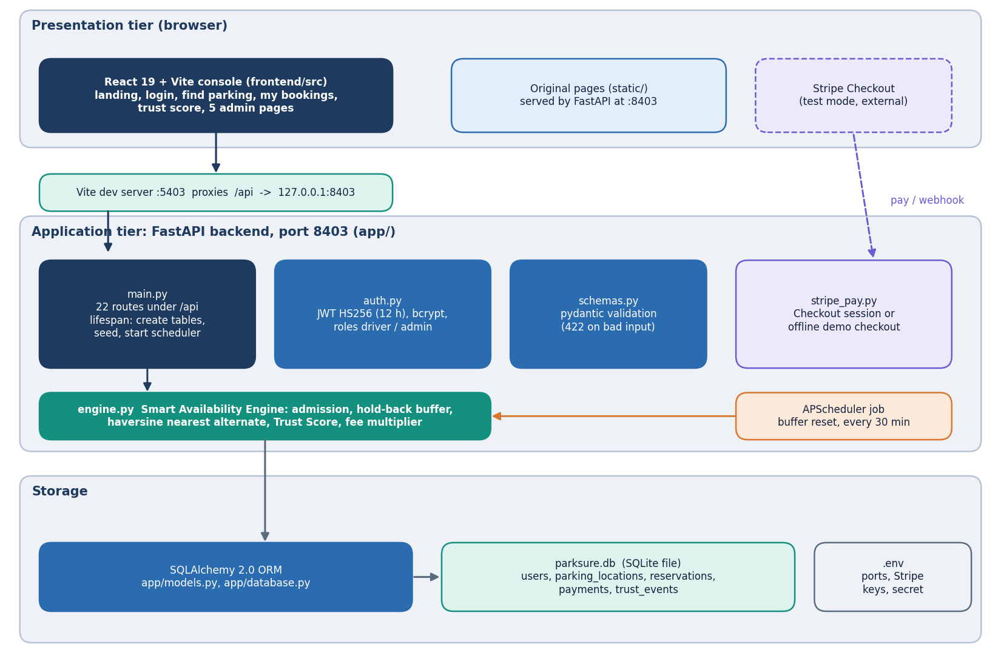
Figure 1: Layered architecture of ParkSure: React console, Vite proxy, FastAPI application with 22 routes, the engine and auth modules, SQLite database, and the Stripe and scheduler side services.
The React console on port 5403 reaches the FastAPI application on 127.0.0.1:8403 through the Vite development proxy, so the browser sees one origin. The application exposes 22 routes in app/main.py. Each route is a thin function: it validates input with pydantic, resolves the caller with a bearer token, calls a function of the engine module or queries the SQLAlchemy session, and returns JSON. The rules themselves live in app/engine.py so that they can be tested without HTTP; the unit tests, the simulator and the Strategy Insights script all import them. The architectural style is a stateless REST interface [24] over one relational store; the only state kept in the server process is the scheduler.
The deliberate gaps in this architecture are worth stating. There is one backend process and one SQLite file, so there is no horizontal scaling and writes are serialised by the database. The admission check and the insert are two separate steps without a lock, which is why the concurrency probe in Chapter 7 found one trial in ten in which two simultaneous requests both took the last bay. The buffer-reset job runs inside the web process, so a second process would run it twice. And entry and exit are software events (the Check in and Check out buttons); there are no barriers, sensors or cameras, so the physical occupancy the arrival check uses is the count of bookings the system itself has marked active.

1.2 High-level workflow
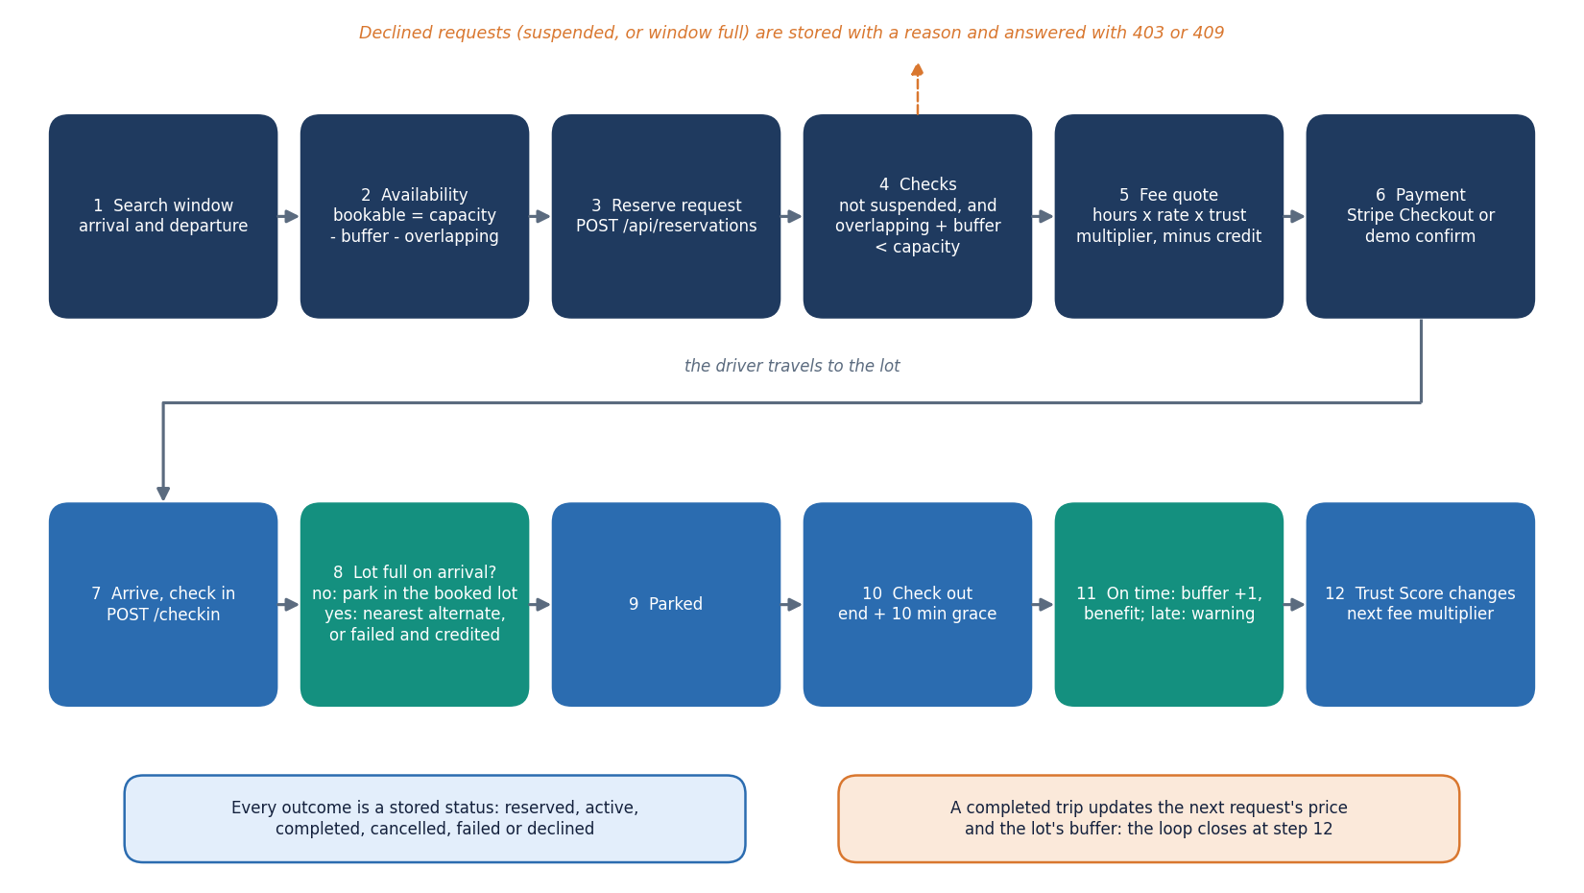
Figure 2: End-to-end workflow: search, reserve, pay, arrive, check in (alternate or fail if full), park, check out, trust update and buffer update.
The workflow has seven stages and every stage maps to a route or a page. Search (GET /api/search, Find parking) shows bookable bays per location for a window. Reserve (POST /api/reservations) applies the suspension check and the admission rule and stores either a reserved or a declined booking. Pay completes through Stripe Checkout in test mode or through the offline demo checkout. Check in (POST /api/reservations/{id}/checkin) activates the booking or triggers the alternate move. Check out judges the departure against the end time plus ten minutes of grace. Trust and buffer update happen in the same call. Analytics (Strategy Insights) replays the stored history for the administrator.
The booking has six states, shown below. Every transition is caused by one API call, and the four final states keep the row for reporting. Two details are easy to miss. A declined request is stored as a row of its own, with the reason in decline_reason, so refused demand is visible to the administrator; and an automatic move to an alternate does not edit the original booking into a new one: the original becomes failed, with the explanation, and a second booking is created as active with parent_id pointing back.
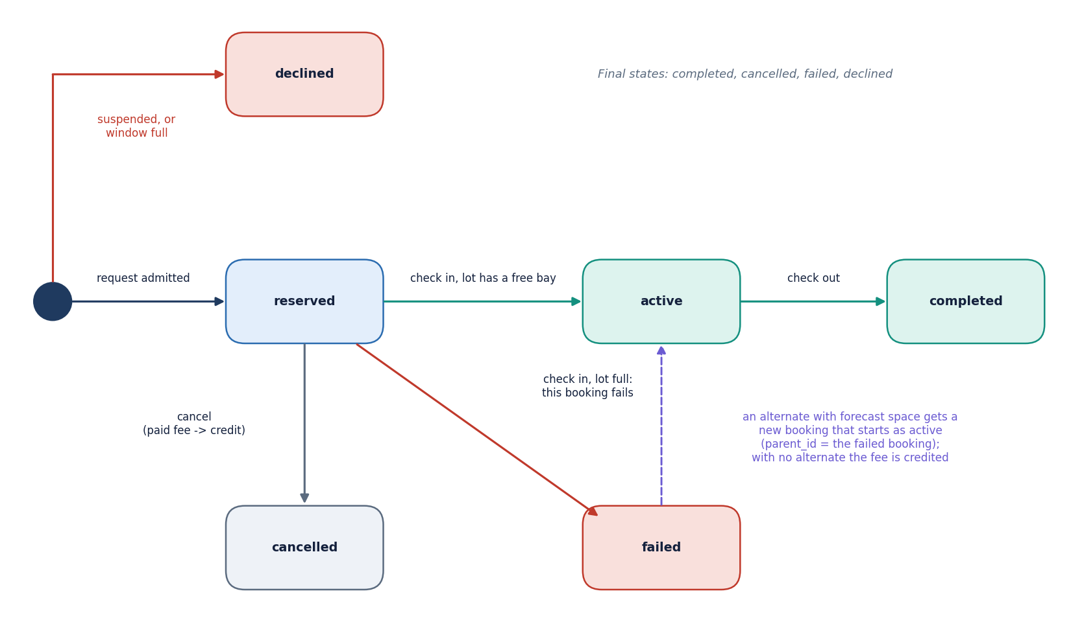
Figure 3: State diagram of a reservation: reserved, active, completed, cancelled, failed and declined, with the events that cause each transition.

1.3 Data flow diagrams

1.3.1 Level 0: context
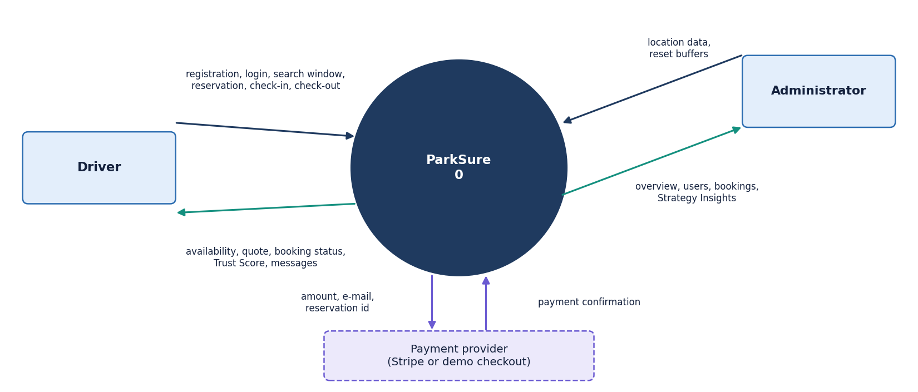
Figure 4: Context diagram (DFD level 0): ParkSure as one process with the driver, the administrator and the payment provider as external entities.
At level 0 ParkSure is one process with three external entities. The driver supplies credentials, search windows and booking actions and receives availability, quotes, booking status, messages and the Trust Score. The administrator supplies location definitions and reset commands and receives overview figures, the user and booking lists and the Strategy Insights replay. The payment provider is Stripe in test mode, or the built-in demo checkout when no key is configured; it receives an amount and a reservation number and returns a confirmation.

1.3.2 Level 1: six processes
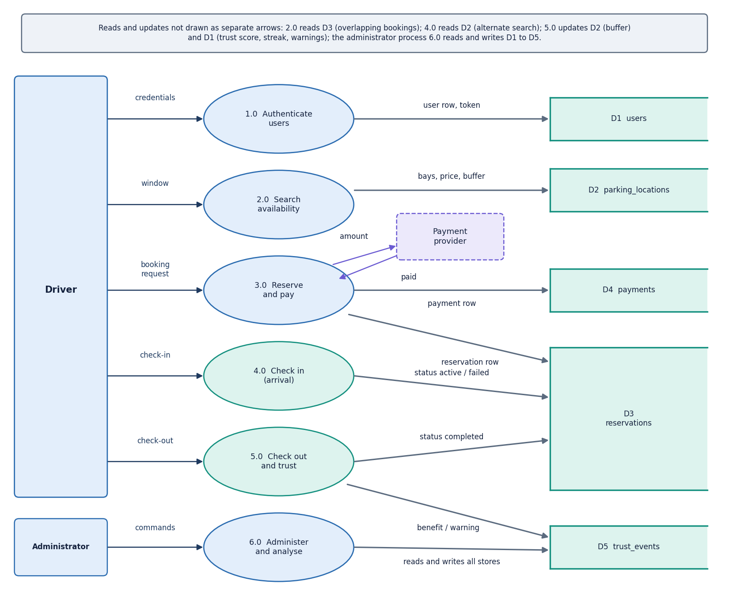
Figure 5: DFD level 1: six processes (authentication, availability search, reservation and payment, check-in and arrival handling, check-out and trust, administration and insights) and the data stores.
Level 1 shows six processes and five data stores. 1.0 Authenticate reads and writes the users store (D1). 2.0 Search availability reads locations (D2) and reservations (D3). 3.0 Reserve and pay writes reservations (D3) and payments (D4). 4.0 Check in reads D2 and D3 and, in the full-lot case, writes a second reservation (D3). 5.0 Check out writes the buffer size back to D2 and appends to the trust events (D5). 6.0 Administer and analyse reads everything and writes only location changes and buffer resets.

1.3.3 Level 2: reservation and payment
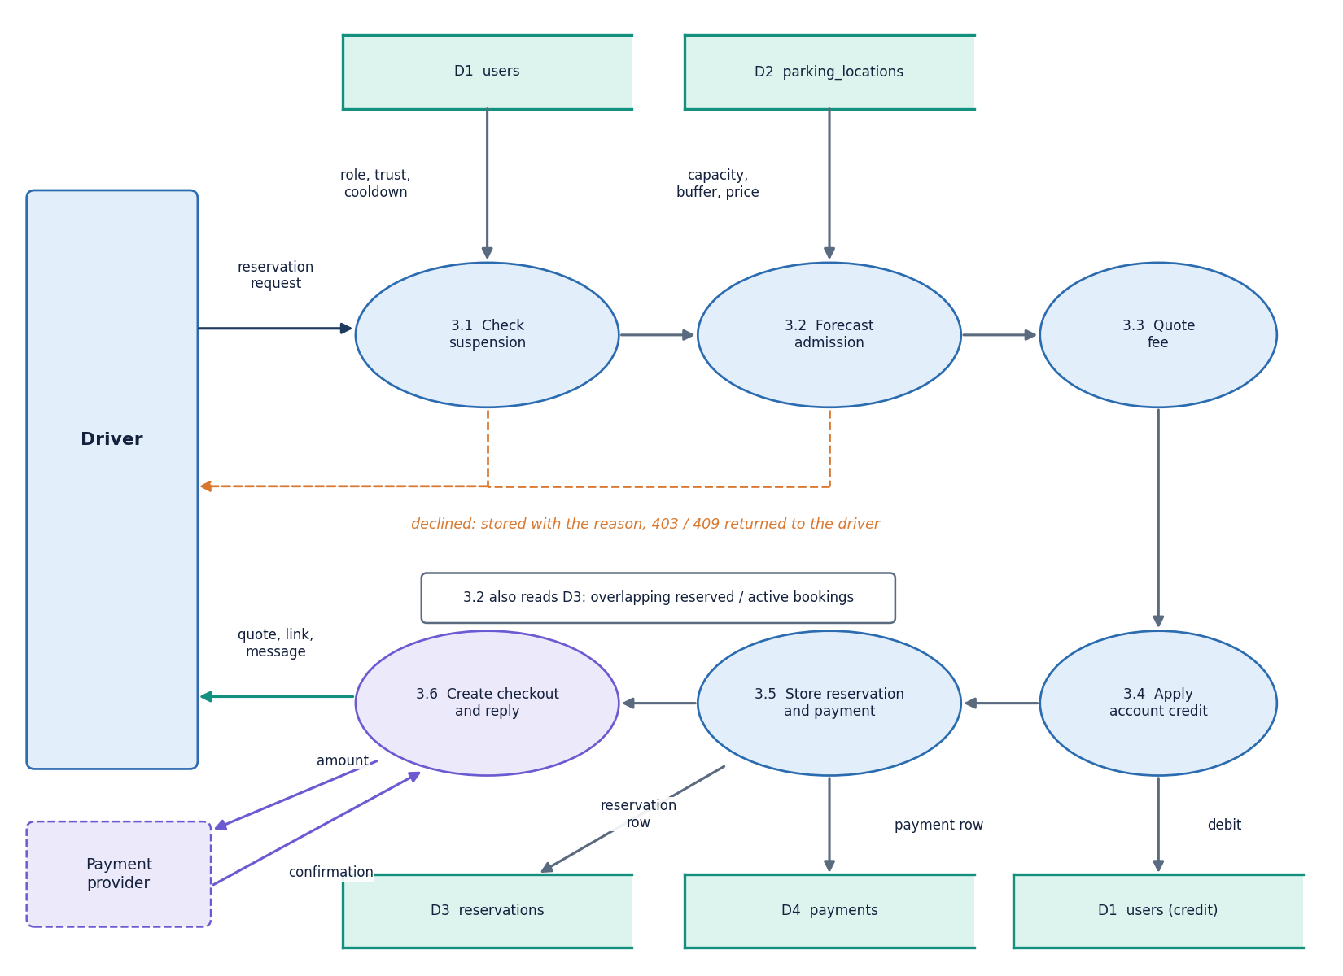
Figure 6: DFD level 2: the reservation and payment process 3.0 expanded into suspension check, forecast admission, fee quote, credit application, payment creation and checkout link.
The reservation process is expanded because it holds the main business rules. Six sub-processes run in a fixed order, and the order matters: the suspension check comes before the admission rule so that a suspended driver never consumes an availability query; the fee is quoted only after admission; and the account credit is applied before the payment row is written, so a booking fully covered by credit is stored as paid and needs no checkout. Both refusals (403 and 409) store a declined booking before raising the error, which is what feeds the declined counter on the admin overview.

1.4 UML design

1.4.1 Class diagram
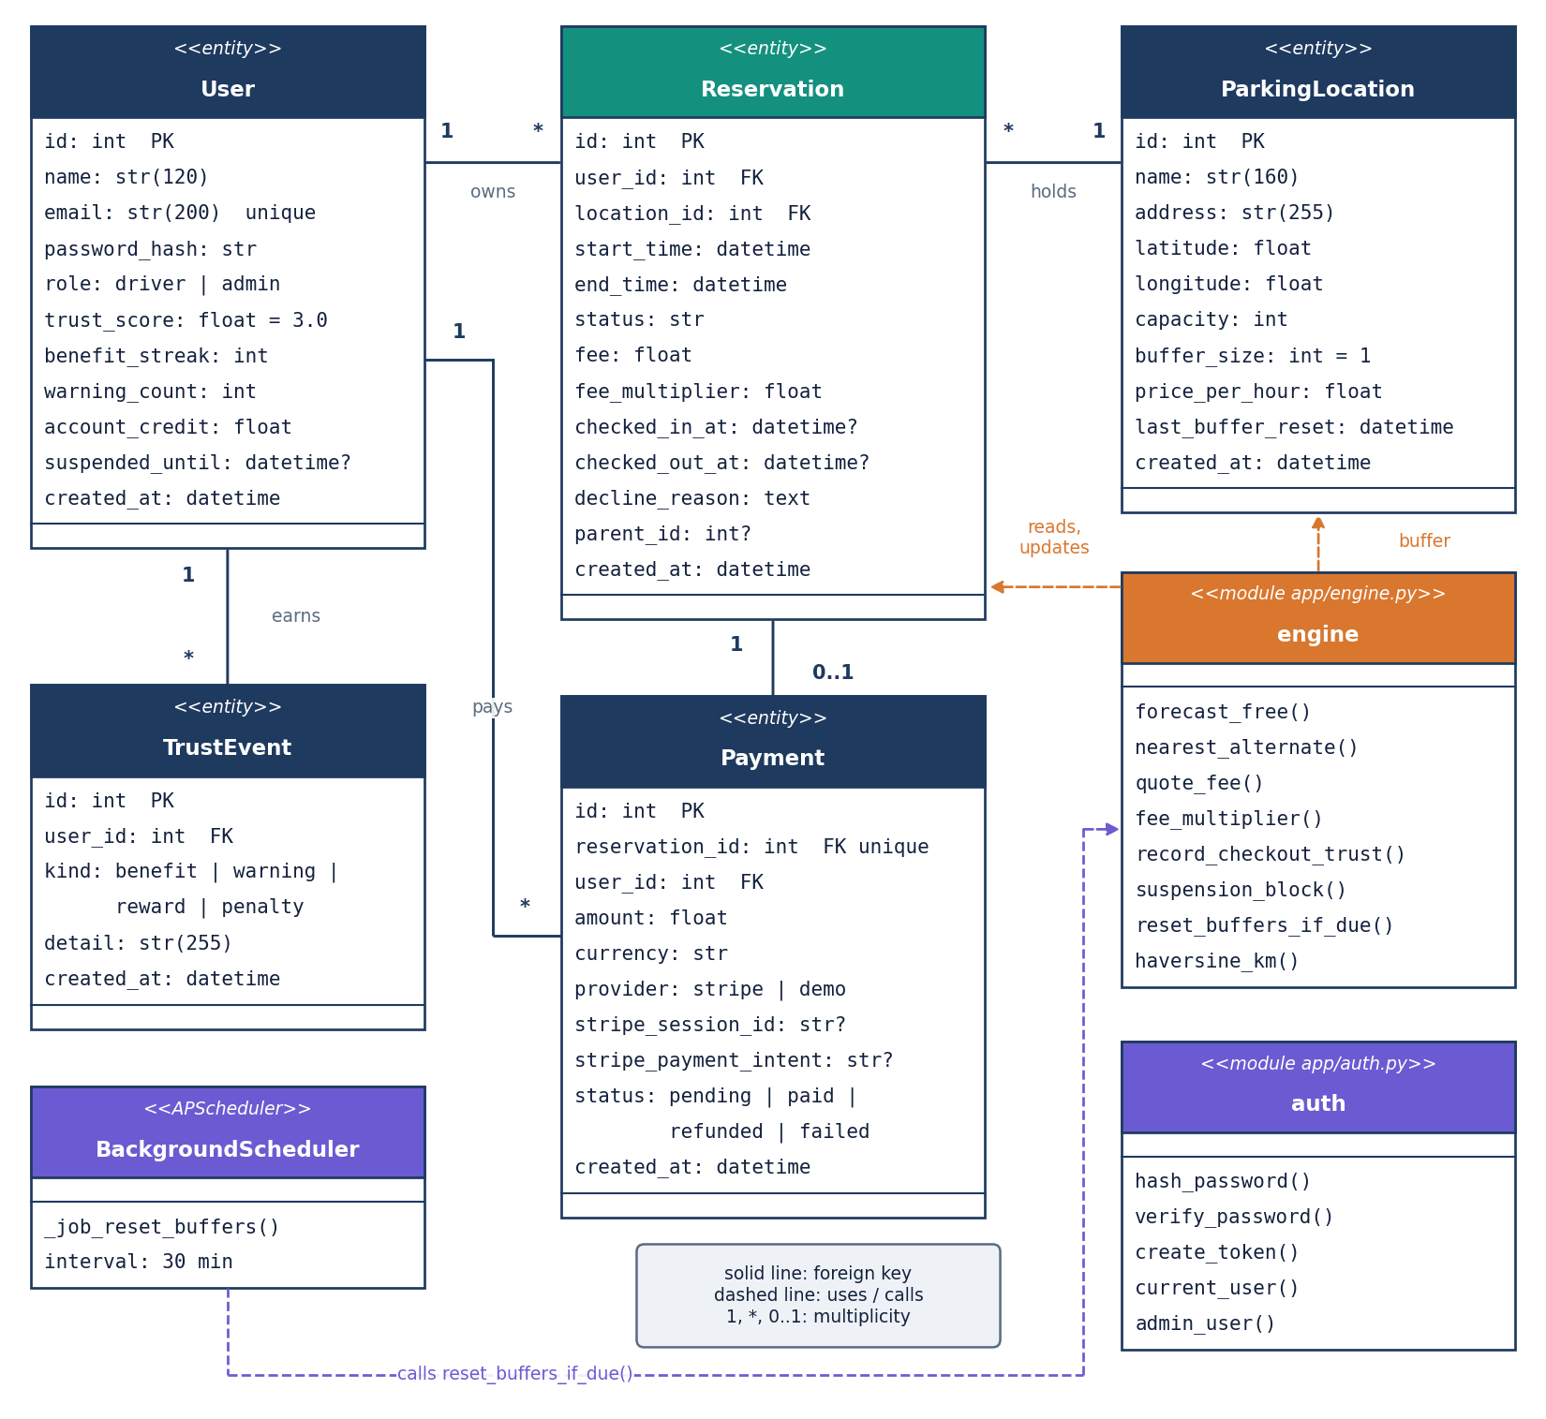
Figure 7: UML class diagram of the five persisted entities (User, ParkingLocation, Reservation, Payment, TrustEvent) and the engine and API modules that operate on them.
The persistence layer is object-relational: five SQLAlchemy classes map to five tables [27]. Behaviour is kept out of the model classes and placed in engine.py as functions that take a session, which makes each rule a plain function that a test can call with an in-memory database. The only other classes are four pydantic input models (RegisterIn, LoginIn, LocationIn, ReservationIn), which carry the length and range limits of the API. The diagram draws the engine, the auth module and the scheduler job as class-like boxes so that the dependencies are visible.

1.4.2 Sequence diagram
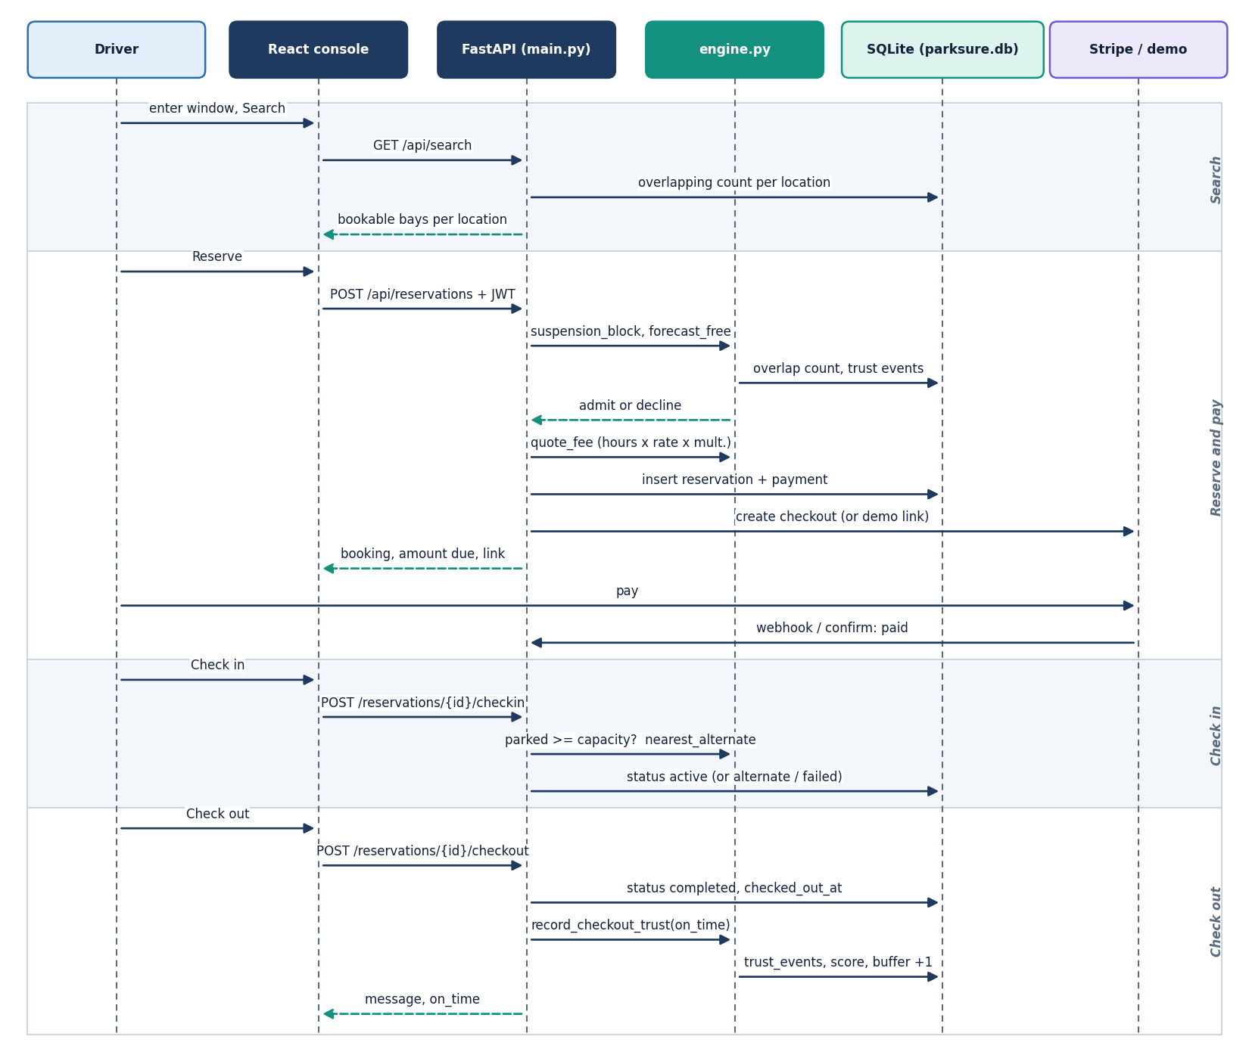
Figure 8: Sequence diagram: reserve, pay, check in, check out and the trust and buffer updates between the driver, the React console, the API, the engine, the database and the payment provider.
The sequence follows one booking from search to check-out. The reservation request passes four gates before any row is written: the token, the existence of the location, the suspension check and the admission rule. The payment is created in the same transaction as the reservation, and the checkout link is requested afterwards, so a failure of the payment provider leaves a booking with a pending payment row instead of a lost booking. At check-out the buffer is updated in the same request as the booking status, then the trust update commits its own events.

1.4.3 Use-case diagram
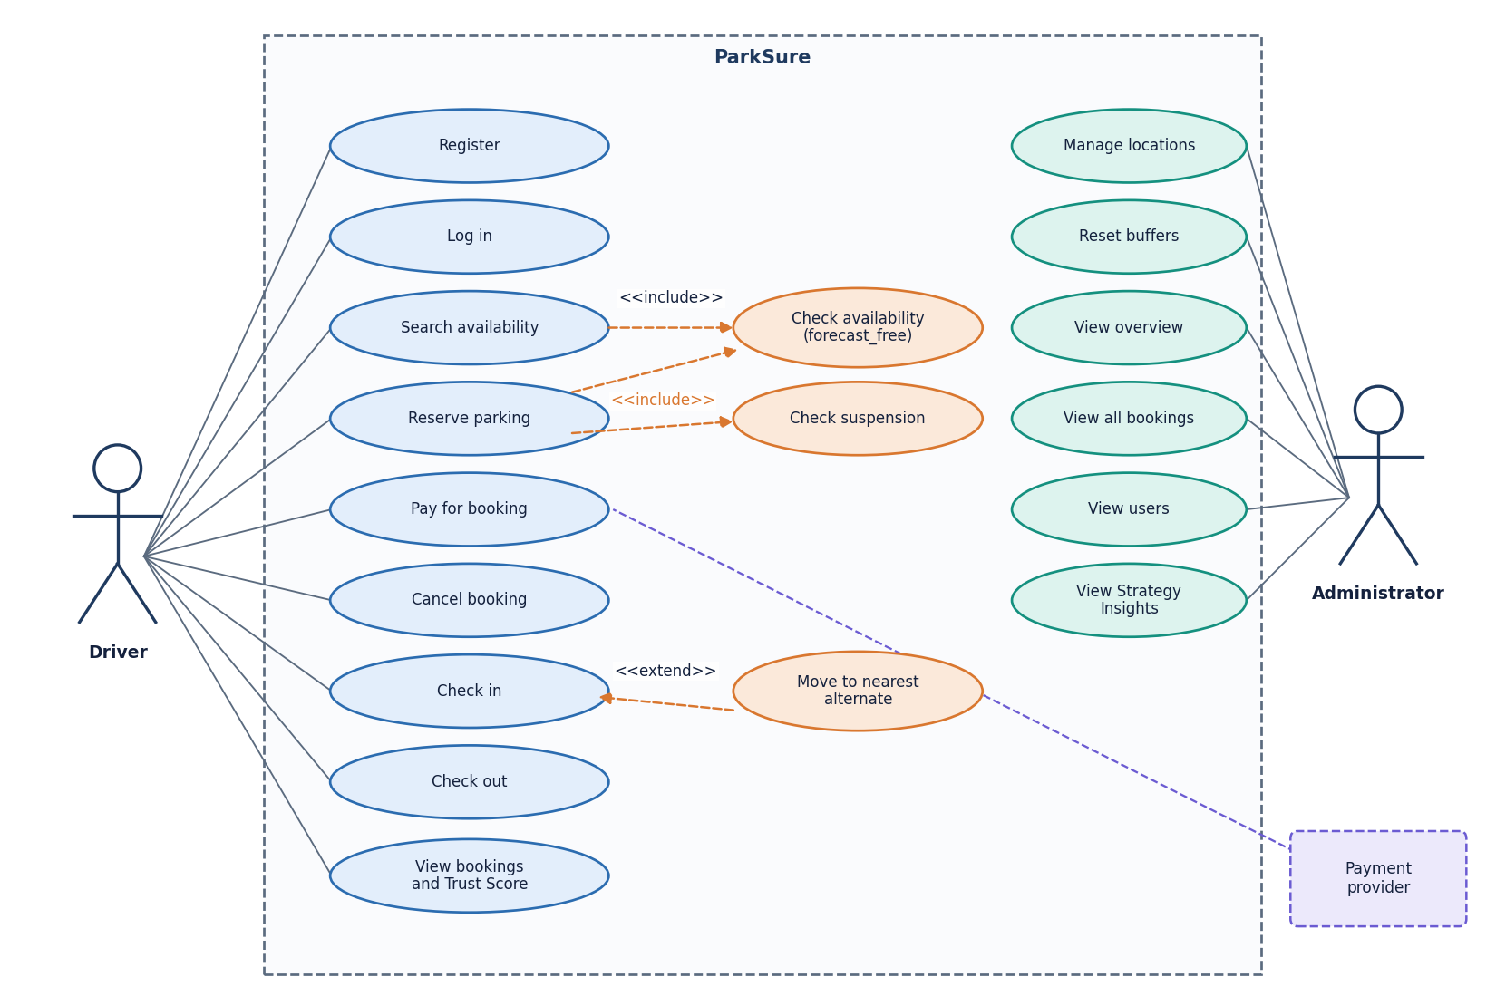
Figure 9: Use-case diagram for the driver, the administrator and the payment provider.
There are two human actors and one system actor. Reserving includes the availability check and the suspension check, and check-in is extended by the alternate move when the lot is full. The administrator account can also use the driver screens (the sidebar shows both groups), but only the admin routes are role-guarded.

1.5 Database design
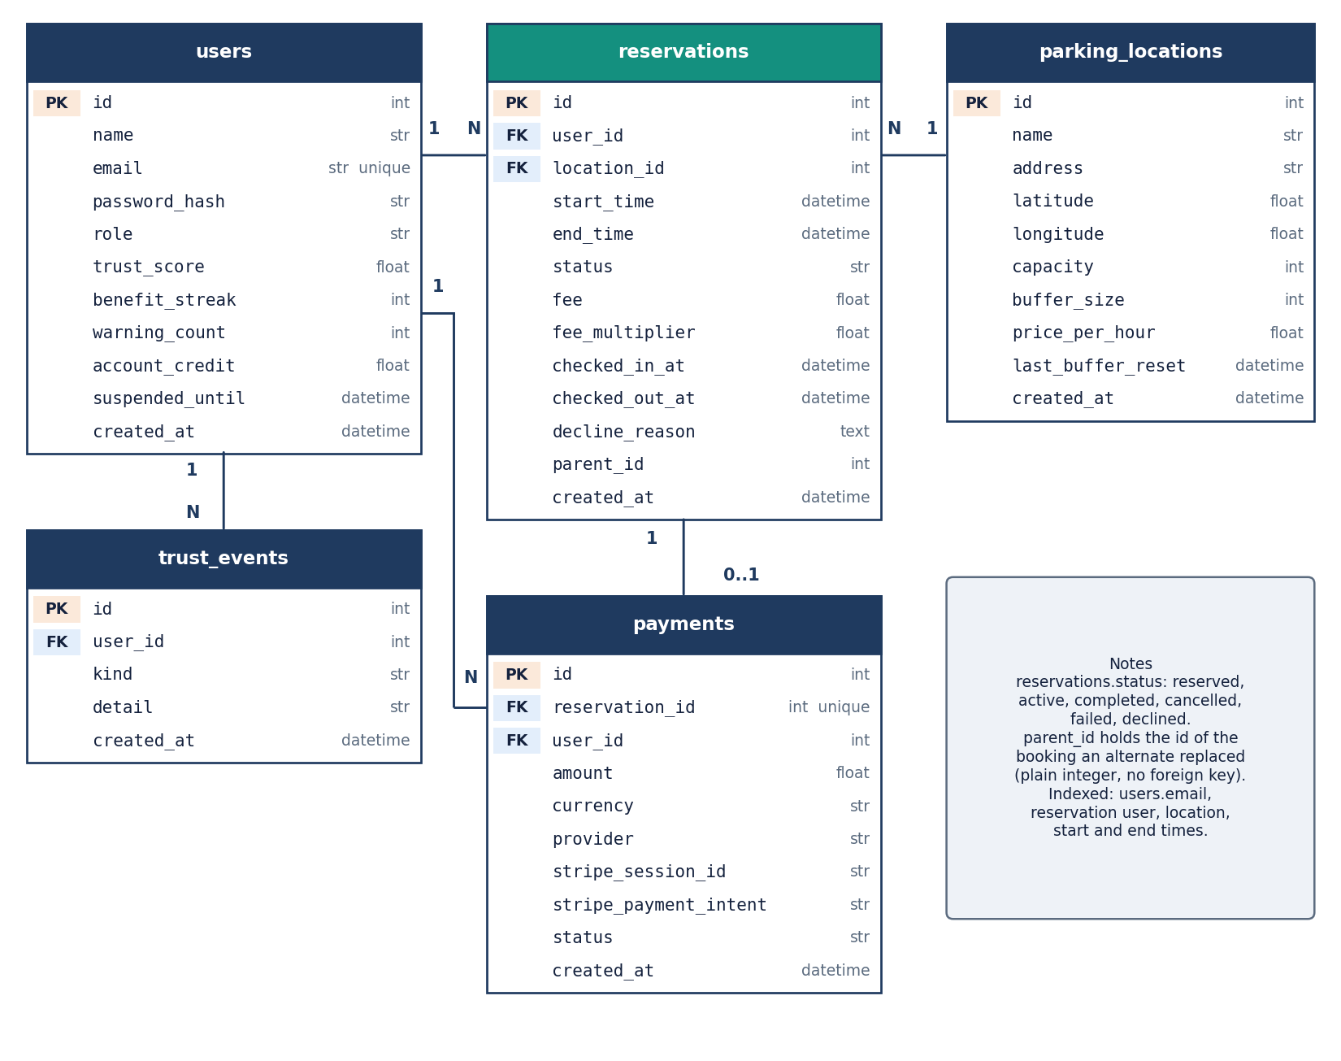
Figure 10: Entity-relationship diagram of the SQLite database: users, parking_locations, reservations, payments and trust_events with keys and cardinalities.
The schema has five tables in one SQLite file, parksure.db; it is created by Base.metadata.create_all at start-up, and the file path can be changed with PARKSURE_DB to point SQLAlchemy at another database. A user has many reservations and many trust events; a location has many reservations; a reservation has at most one payment (a unique foreign key). Deleting a user or a location cascades, through the ORM, to the reservations and events that belong to it.
Table 2: The five tables and their columns.
Table | Columns | Keys, indexes, defaults
users | id, name(120), email(200), password_hash(255), role(20), trust_score, benefit_streak, warning_count, account_credit, suspended_until, created_at | PK id; unique index on email; role driver or admin; trust_score 3.0; streak, warnings and credit 0
parking_locations | id, name(160), address(255), latitude, longitude, capacity, buffer_size, price_per_hour, last_buffer_reset, created_at | PK id; buffer_size 1; price 3.0; capacity limited to 1-5,000 by the schema
reservations | id, user_id, location_id, start_time, end_time, status(30), fee, fee_multiplier, checked_in_at, checked_out_at, decline_reason, parent_id, created_at | PK id; FK user_id and location_id; indexes on user, location, start and end; status reserved; parent_id is a plain integer
payments | id, reservation_id, user_id, amount, currency, provider(20), stripe_session_id, stripe_payment_intent, status(30), created_at | PK id; unique FK reservation_id; provider demo or stripe; status pending, paid, refunded or failed
trust_events | id, user_id, kind(20), detail(255), created_at | PK id; FK user_id (indexed); kind benefit, warning, reward or penalty

Three design points deserve a note. The reservation window is stored as two timezone-aware timestamps and the overlap test is the half-open interval comparison start < other_end AND end > other_start, so a booking that ends at 14:00 does not conflict with one that starts at 14:00. The hold-back buffer is a column of the location, not a computed value, because it is state that grows and is reset by the scheduler. And the fee is stored on the reservation together with the multiplier that produced it, so a later change to the driver's score does not rewrite the price of an old booking.

1.6 Core algorithm design
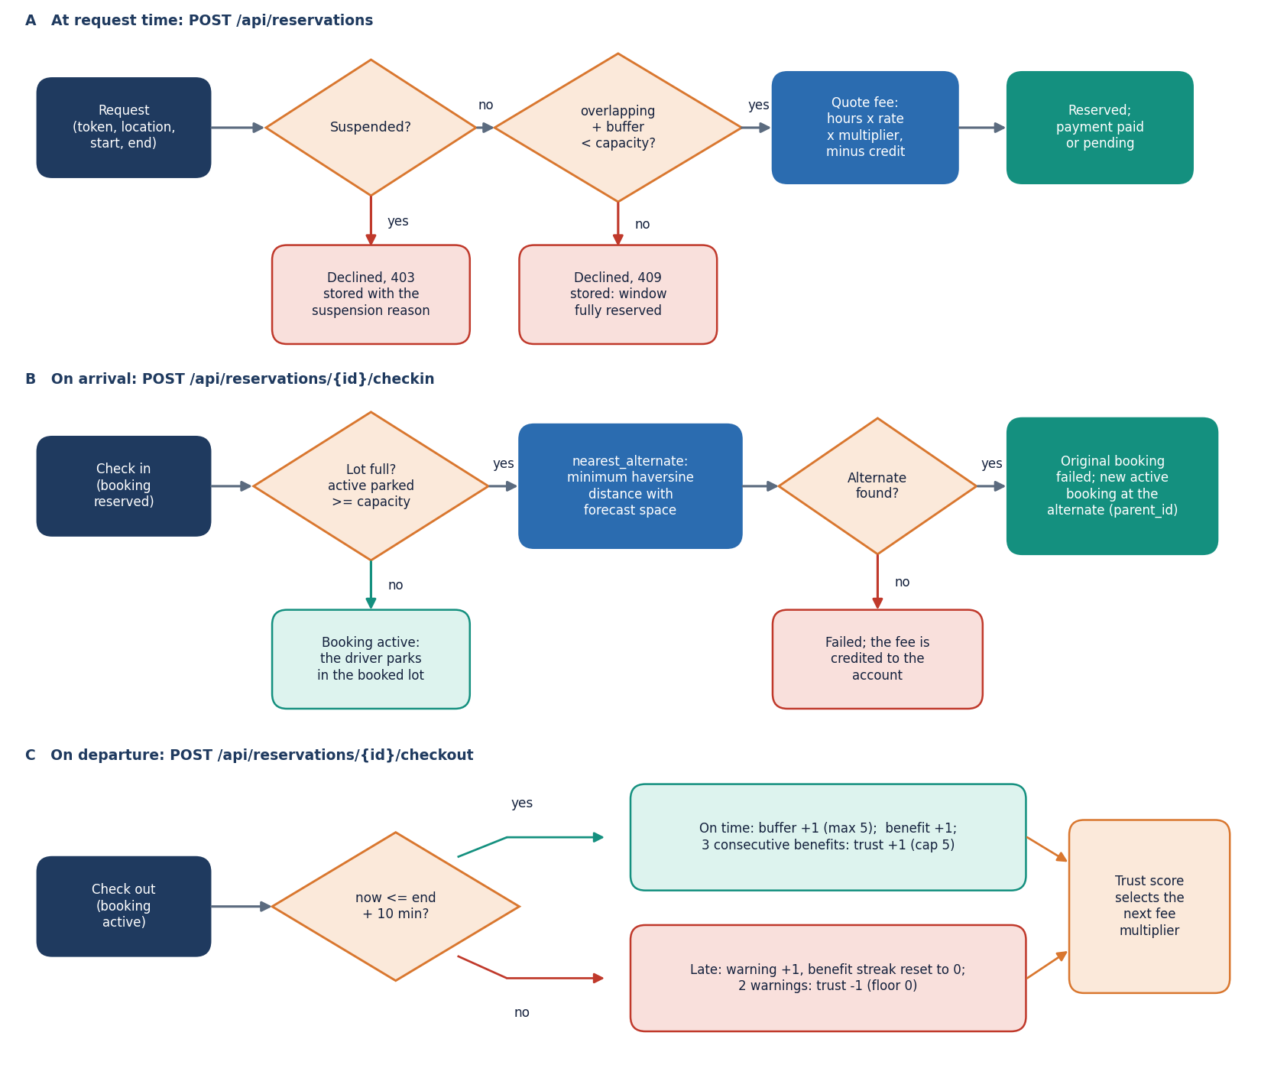
Figure 11: Flowchart of the Smart Availability Engine: suspension check, admission rule, fee quote, arrival check, nearest-alternate search, departure check, buffer growth and trust update.
The engine makes three decisions at three moments. At request time it refuses a suspended driver and applies the admission rule: the number of reserved and active bookings that overlap the window plus the location's buffer must be smaller than its capacity. This is interval-overlap counting, the simplest form of the interval scheduling that [2] attributes to earlier reservation work [7]; the buffer is what turns it into a rule that tolerates overstays. At arrival time it compares the number of bookings marked active at the location with its capacity; if the lot is full it scans every other location, keeps those whose own admission rule would accept the window, and books the one with the smallest great-circle distance [23]. At departure time it compares the checkout instant with the end time plus ten minutes, grows the buffer on an on-time departure and updates the Trust Score.
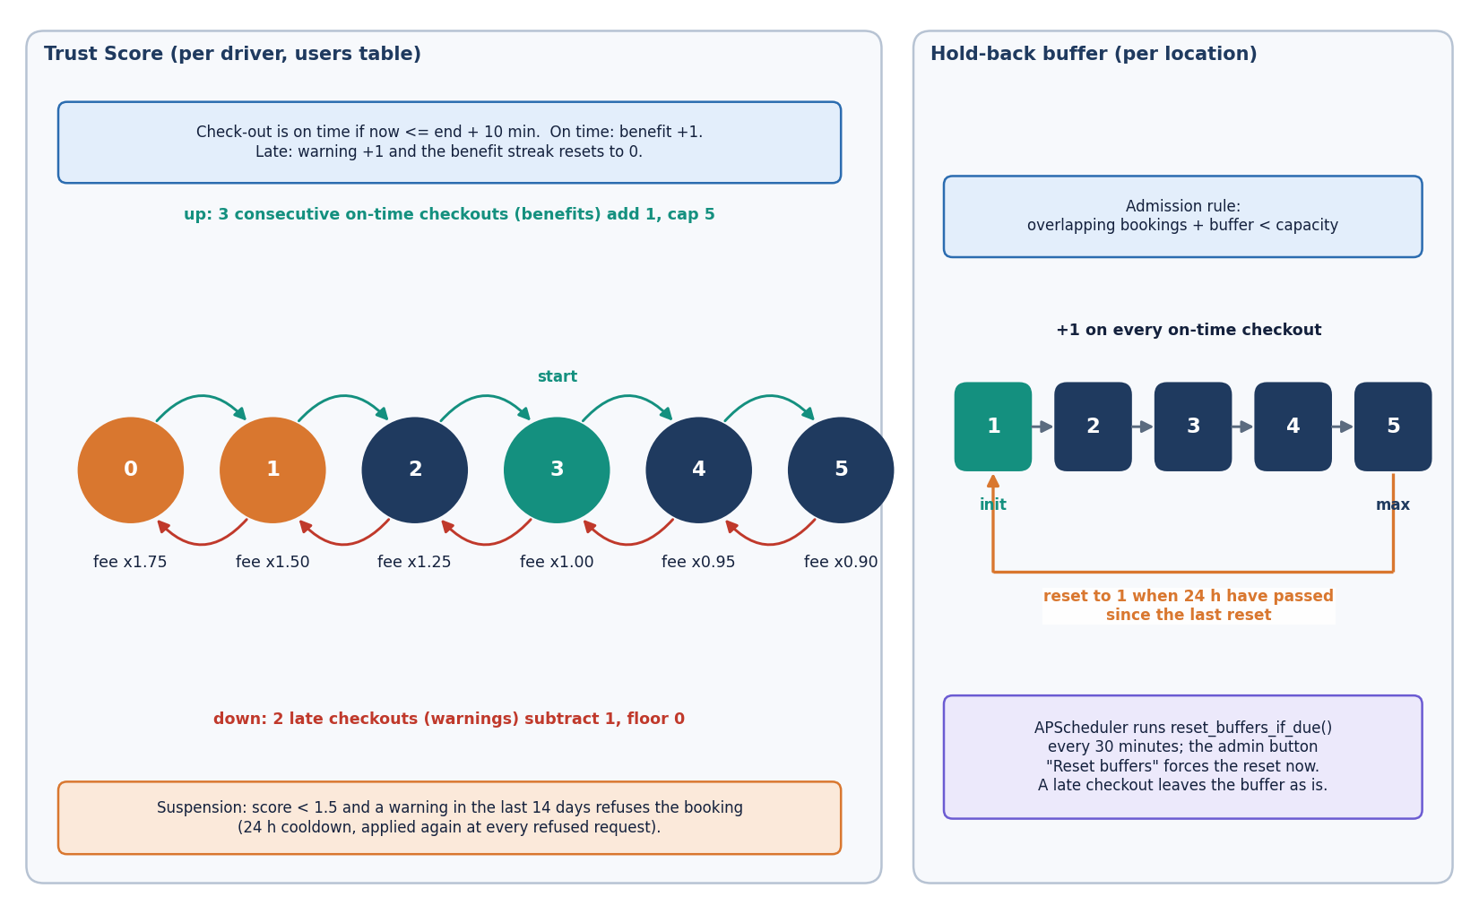
Figure 12: Trust Score state machine (benefit streak, warning count, score 0-5, fee multiplier, suspension rule) and the per-location buffer policy (initial value, growth, cap and daily reset).
The Trust Score and the buffer are the two feedback loops. The score changes the fee multiplier from 1.75 at score 0 to 0.90 at score 5, so a driver who ends sessions late pays more and is eventually suspended; the buffer changes the number of bookable bays at the location. A consequence of the shipped design, measured in Chapter 8, is that the buffer rises when departures are on time, whereas the dynamic rule in [2] raises it when departures are late. The diagram shows the rule as implemented. The design keeps the alternate search simple on purpose, following the same paper: exactly one alternate is offered, because a second alternate would be too far from the driver's destination to be useful.

1.7 Module design
The code is split so that each file has one reason to change. Line counts below were measured from the repository when this report was built.
Table 3: Modules, sizes and responsibilities.
Module | Lines | Responsibility
app/main.py | 440 | FastAPI application: 22 routes, lifespan (create tables, seed, scheduler), static serving
app/engine.py | 141 | Smart Availability Engine: overlap count, admission, haversine, nearest alternate, buffer reset, trust update, suspension, fee quote
app/models.py | 93 | Five SQLAlchemy models: User, ParkingLocation, Reservation, Payment, TrustEvent
app/auth.py | 53 | bcrypt hashing, JWT creation and decoding, current_user and admin_user guards
app/schemas.py | 40 | pydantic input models with length and range limits
app/stripe_pay.py | 35 | Stripe Checkout session in test mode, or the offline demo checkout
app/config.py | 43 | Policy constants (buffer, trust, fee multipliers) and secrets read from the environment
app/database.py | 18 | SQLite engine, session factory and the get_db dependency
app/seed.py | 114 | Seeded demo data: 5 locations, 1 admin, 8 drivers, 60 days of booking history
scripts/compute_buffer_strategy_metrics.py | 119 | Deterministic replay of stored bookings under four buffer policies (Strategy Insights)
scripts/parking_sim.py, scripts/parity.py | 276 | Discrete-event simulator of the reservation rules and its parity check against the engine
scripts/run_experiments.py, scripts/measure_api.py | 205 | Experiments, API latency, concurrency and security probes
scripts/smoke_test.py | 114 | 27-check end-to-end test on a throw-away database
frontend/src/ | 6,494 | React 19 console: 11 page components, UI kit, charts, three.js hero, API client, auth and theme providers
tests/ | 642 | 70 pytest tests (29 engine, 36 API, 5 simulator parity)

Three decisions about this structure are worth recording. The rules sit in one module with no web imports, so the simulator in scripts/parking_sim.py can import the pure functions (haversine, fee multiplier) and a parity test can run the stateful ones against an in-memory database. The experiment scripts and the tests exercise the product's own functions and routes, not copies of them. And the console has its own small UI kit (buttons, cards, tables, badges, toasts, modals), so the pages contain layout and calls and no styling.

1.8 API design
All routes live under /api. Reads are GET and actions are POST; the three location-management routes use PUT and DELETE. Failures return the FastAPI detail string, which the console shows verbatim, so error messages are written for the driver, for example 'Booking paused until ... after a recent late checkout.' or '... is fully reserved for the requested window'. The status codes follow one rule set: 401 means the token is missing or invalid, 403 means the role or the Trust Score does not allow the action, 404 means the object does not exist or does not belong to the caller, 409 means the window is full, 400 means the request is well formed but not acceptable, and 422 means input validation failed.
Table 4: The 22 routes of the ParkSure API.
Method | Path | Who | Purpose | Errors
POST | /api/auth/register | - | Create a driver account (the first account on an empty database becomes admin); returns token and user | 400 duplicate email; 422 validation
POST | /api/auth/login | - | Check the bcrypt hash; returns token and user | 401 wrong email or password
GET | /api/auth/me | user | Profile with trust score, streak, warnings, credit, suspension time | 401
GET | /api/locations | - | All locations, ordered by name | -
POST | /api/locations | admin | Create a location | 403; 422
PUT | /api/locations/{id} | admin | Update a location | 403; 404; 422
DELETE | /api/locations/{id} | admin | Delete a location and, by cascade, its reservations | 403; 404
GET | /api/search | - | Per location: overlapping bookings, bookable bays, available flag for a time window | 400 end before start or window over 30 days; 422
POST | /api/reservations | user | Suspension check, admission rule, fee quote, credit, payment record, checkout link | 403 suspended; 409 full; 404; 400; 422
GET | /api/reservations | user | The caller's reservations, newest window first | 401
POST | /api/reservations/{id}/cancel | owner or admin | Cancel a reserved booking; a paid fee returns as account credit | 404; 400 not cancellable
POST | /api/reservations/{id}/checkin | owner or admin | Activate; if the lot is physically full, move to the nearest alternate or fail and credit | 404; 400 not reserved
POST | /api/reservations/{id}/checkout | owner or admin | Complete; on time or late; buffer and trust update | 404; 400 not active
GET | /api/trust | user | Score, streak, warnings, next reward, fee multiplier and the last 20 trust events | 401
GET | /api/payments/demo-confirm | - | Offline demo checkout link: marks the payment paid | 404
POST | /api/payments/{id}/confirm | owner or admin | Confirm a payment from the console | 404; 403
POST | /api/stripe/webhook | Stripe signature | On checkout.session.completed mark the payment paid | 400 bad signature; inert without keys
GET | /api/admin/overview | admin | Counts of users, locations, reservations, paid revenue, unable-to-park, declined | 403
GET | /api/admin/users | admin | All users with trust and credit | 403
GET | /api/admin/bookings | admin | The 300 most recent reservations | 403
POST | /api/admin/reset-buffers | admin | Reset buffers by policy, or force a reset | 403
GET | /api/admin/insights | admin | Deterministic replay under four buffer policies for a window of days | 403

GET /api/search and GET /api/locations need no login, so that the landing page can show live capacity. GET /api/admin/insights takes a window in days and is the only route that runs a simulation; it replays each location's stored bookings under no buffer, fixed buffers of one and three, and the dynamic rule, and returns the counts per location and in total.

1.9 User interface design
The console has eleven page components: a public landing page, a login page with sign-in and registration tabs, three driver pages (Find parking, My bookings, Trust score), five administrator pages (Overview, Locations, Strategy insights, All bookings, Users) and a not-found page. A role guard hides the administrator group from drivers, and a 401 from the API clears the session and returns to the login page. The visual language is a dark-first interface with a light theme, one accent colour, a three.js hero on the landing page and a static fallback image for users who prefer reduced motion.
Table 5: Pages, routes and the endpoints they use.
Page | Route | Endpoints used
Landing | / | GET /api/locations (live capacity and location names)
Login and registration | /login | POST /api/auth/login, POST /api/auth/register
Find parking | /app/find | GET /api/search, POST /api/reservations, GET /api/trust
My bookings | /app/bookings | GET /api/reservations, POST /api/reservations/{id}/cancel, checkin, checkout, POST /api/payments/{id}/confirm
Trust score | /app/trust | GET /api/trust
Admin overview | /app/admin | GET /api/admin/overview, GET /api/admin/insights
Admin locations | /app/admin/locations | GET, POST, PUT, DELETE /api/locations, POST /api/admin/reset-buffers
Strategy insights | /app/admin/insights | GET /api/admin/insights
All bookings | /app/admin/bookings | GET /api/admin/bookings
Users | /app/admin/users | GET /api/admin/users

Four design rules were applied to every working page. Each page opens with its purpose in one sentence. Long actions show a busy state and finish with a toast, and the toast names the consequence (for example 'Moved to Central Station Garage'). Money and times are formatted the same way everywhere, and a booking's status is a coloured badge with the reason beneath it when it is declined or failed. Errors from the API appear in an inline panel with a retry button. Chapter 8 shows the working pages with real data; the screens below illustrate the design itself.
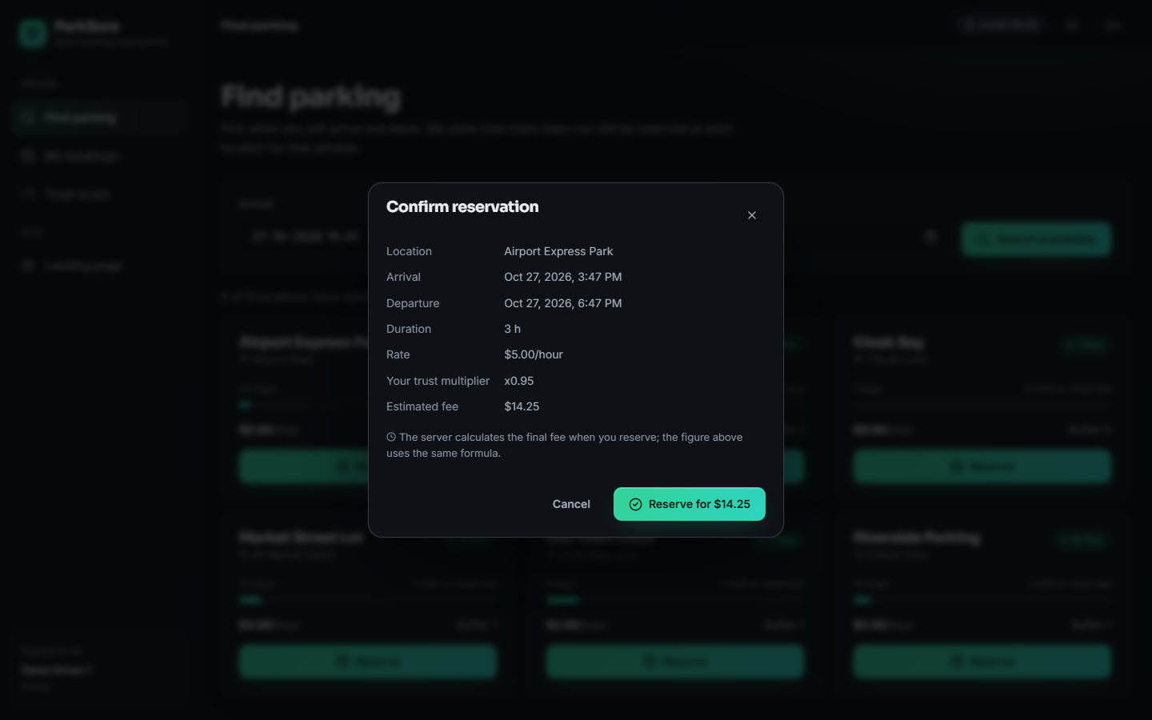
Figure 13: Reserve dialog on the Find parking page: the estimate uses the same formula as the server (hours x rate x trust multiplier).
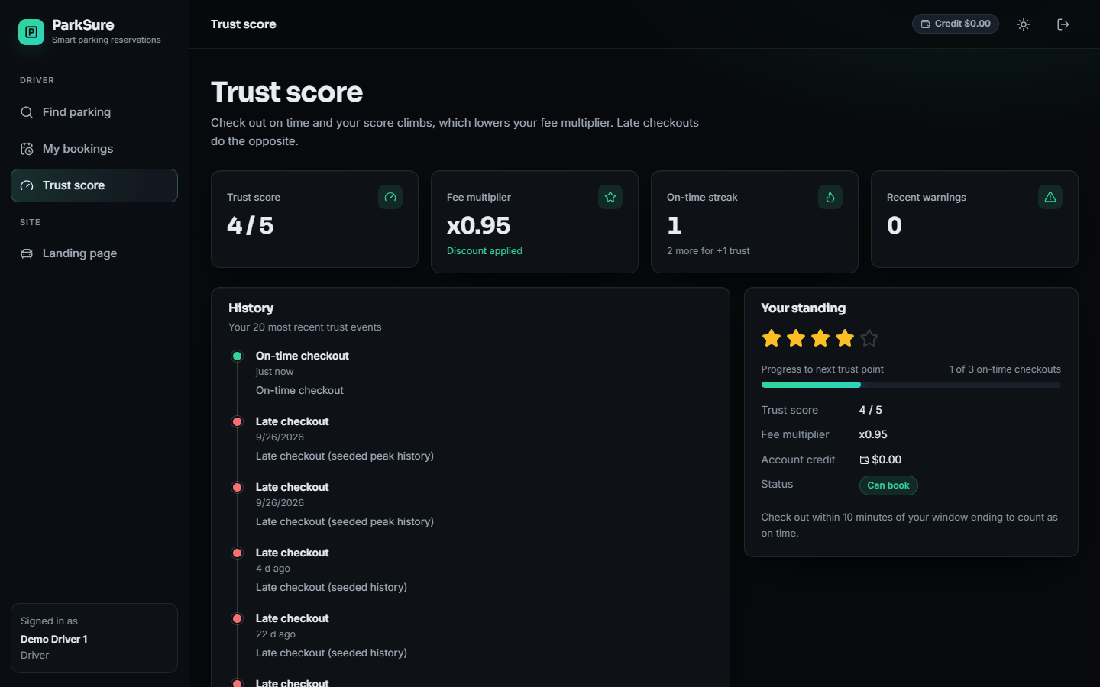
Figure 14: Trust score page: score, fee multiplier, benefit streak and the event timeline.
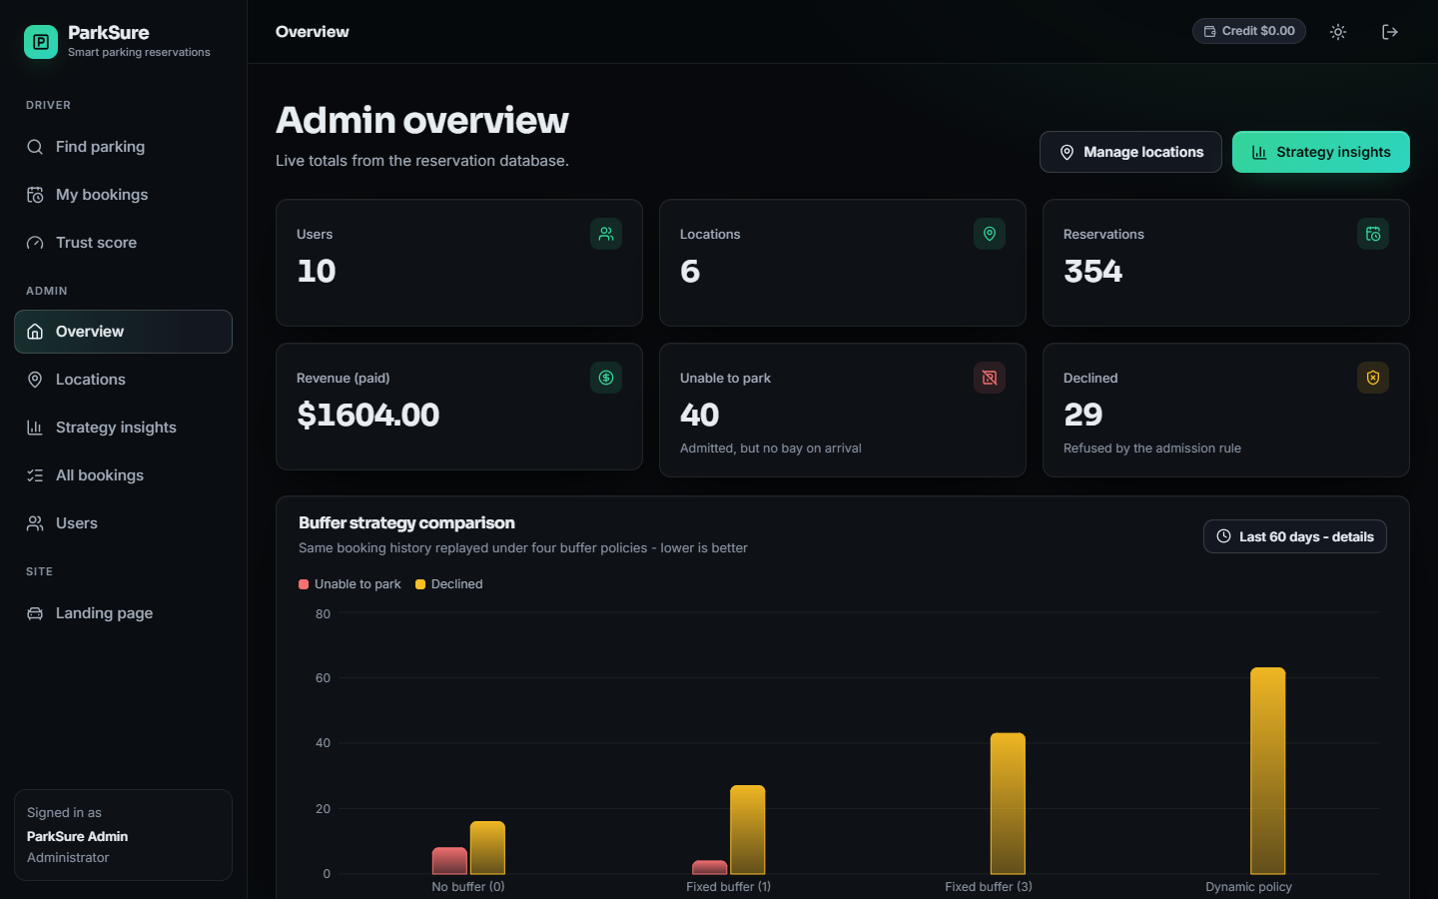
Figure 15: Admin overview: totals read live from the reservation database.

1.10 Design decisions and trade-offs
Every design has costs. The table records the main decisions, what each bought and what it cost, so that the limitations in Chapter 9 can be traced back to a choice and not to an accident.
Table 6: Principal design decisions.
Decision | Reason | Cost
Keep the rules in engine.py, separate from the routes | Each rule is testable with an in-memory database; the simulator and the replay reuse the same functions | Two rules (buffer growth and the late test) are still written inside the check-out route
SQLite with create_all and seeded data | Zero configuration; a clean database is re-seeded on first start | One writer at a time; no migrations; the admission check and the insert are not atomic
Admit on forecast (overlapping bookings plus buffer), check physical space only on arrival | Cheap, deterministic, explainable to the driver; no sensors needed | The arrival check counts bookings marked active, not real cars; the alternate is booked without re-checking its own bays
One nearest alternate by haversine distance | Follows the base paper; no routing service or external API | Straight-line distance, not driving distance; no choice for the driver
Fee multiplier and suspension from the Trust Score | Gives drivers a price signal for punctuality | A suspended driver is locked out for at least 14 days after the last warning because the check repeats at each request
Stripe test mode with an offline demo checkout | Everything works without keys; the demo is labelled in the interface | The demo confirmation route is not authenticated (Chapter 7 reports it)
Deterministic Strategy Insights replay | The same stored history always gives the same counts, so results can be checked | It replays seeded history; its 45-minute overstay linger is a model, not a measurement

Two further choices concern what was left out. There is no vehicle profile (plate, model) and no downloadable receipt: the batch objectives mention both, and the delivered design stores only the payment record. There is also no live occupancy feed, so 'real-time availability' means the forecast of bookable bays for a chosen window, computed from stored bookings at the moment of the request. These are stated plainly as the gap between the objectives and the delivered design.

2. IMPLEMENTATION

2.1 Application architecture
The product is a single backend process and a browser console. The FastAPI application (app/main.py, port 8403) [28] exposes the 22 routes and also serves the original vanilla pages from static/. The React 19 console (port 5403, Vite) is the interface used in this report. SQLAlchemy 2 maps the five tables to SQLite [27]; APScheduler runs the buffer-reset job; python-jose signs the tokens; bcrypt hashes the passwords; the Stripe SDK creates Checkout sessions.
Figure 16: Layered architecture of ParkSure: React console, Vite proxy, FastAPI application with 22 routes, the engine and auth modules, SQLite database, and the Stripe and scheduler side services.
The backend is organised around one idea: a route does only HTTP work and the rules live in the engine. Every route that changes data receives a database session through the get_db dependency, which opens a session per request and closes it afterwards. Protected routes add the current_user or admin_user dependency. The lifespan hook creates the tables, seeds an empty database and starts the scheduler, and stops it again on shutdown.
def forecast_free(db, loc, start, end) -> bool:
"""A slot will be free at arrival if overlapping bookings + buffer < capacity."""
used = overlapping_count(db, loc.id, start, end)
return (used + loc.buffer_size) < loc.capacity

The console reads the session from a React context. The token is kept in the browser's local storage (every access is wrapped in try/catch so a blocked storage only shortens the session); a single api() wrapper adds the bearer header, turns FastAPI error details into readable messages and reports status 0 when the server cannot be reached ('Cannot reach the ParkSure server. Make sure the backend is running on port 8403.'). A 401 on an authenticated call clears the session. Pages are loaded lazily by route.

2.2 API design
Chapter 5 lists the 22 routes. This section shows the exchange that matters most, the reservation. The request is a three-field document. The response is the booking as the console displays it plus the payment information, so the page needs no second call. The exchange below was recorded from the running application on 2026-10-26 (Market Street Lot, two hours at 3.00 dollars an hour, a driver with Trust Score 3).
POST /api/reservations Authorization: Bearer <token>
{ "location_id": 2, "start_time": "2026-11-02T09:00:00+00:00", "end_time": "2026-11-02T11:00:00+00:00" }

200 OK
{ "id": 355, "location_id": 2, "location_name": "Market Street Lot",
"start_time": "2026-11-02T09:00:00+00:00", "end_time": "2026-11-02T11:00:00+00:00",
"status": "reserved", "fee": 6.0, "fee_multiplier": 1.0,
"checked_in_at": null, "checked_out_at": null, "decline_reason": "", "parent_id": null,
"payment_status": "pending", "payment_provider": "demo",
"credit_applied": 0.0, "amount_due": 6.0,
"checkout": { "url": "/api/payments/demo-confirm?session_id=demo_71d377a3e477&reservation_id=355",
"session_id": "demo_71d377a3e477", "provider": "demo" },
"stripe_configured": false }

When the window is full the same route answers with a conflict and stores a declined booking, so the refusal is visible on the administrator's overview:
409 Conflict
{ "detail": "Kiosk Bay is fully reserved for the requested window (capacity 1, hold-back buffer 0). Please
try another time or location." }

The search route returns, for each location, the numbers the cards show: capacity, buffer_size, overlapping, bookable and available. The check-in route returns {moved, reservation, message} and, when the booking was moved, alternate and distance_km; when no alternate exists it returns {moved: false, failed: true, reservation, message}. The trust route returns the score, streak, warnings, next_reward_in, fee_multiplier and the last 20 events.
Measured behaviour (127.0.0.1, single process, SQLite, 200 sequential requests per endpoint; Chapter 7 gives the full table): search 5.7 ms mean, reservation 19.6 ms, check-in 14.9 ms, check-out 14.6 ms, login 220 ms (bcrypt cost 12, intentionally slow), the administrator's insights replay 60 ms. Two routes are slow because they build each row with two further queries: the driver's booking list (180 ms for about 400 stored rows) and the administrator's list of the 300 latest bookings (273 ms). Eight parallel clients reached 131 search requests per second.
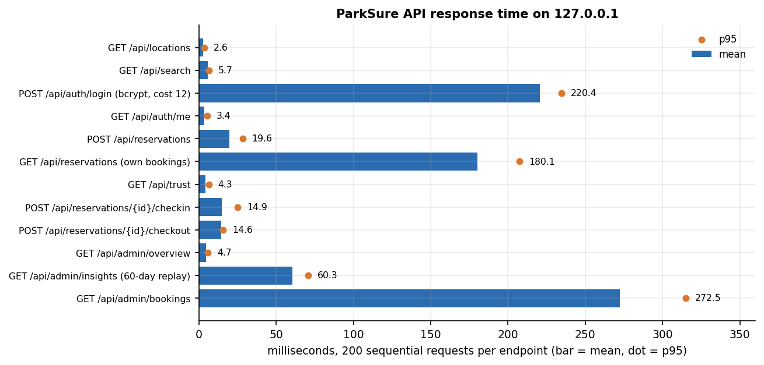
Figure 17: Measured mean and 95th-percentile response time of each endpoint (127.0.0.1, 200 sequential requests).

2.3 Security and error handling
ParkSure is a multi-user application and its security model is correspondingly larger than a single-user tool's. We list what exists, and then what the project's own probes found missing.
• Passwords. Hashed with bcrypt (cost 12) [26]; the plain password is never stored or logged. A failed login returns the same message for an unknown e-mail and a wrong password.
• Sessions. A JSON Web Token [25] signed with HS256 carries the user id, the role and a 12-hour expiry. Authorisation does not trust the role claim: admin_user reads the role from the database on every request.
• Role guards and ownership. Eight routes need a login and eight need the admin role (the five administrator routes and the three location-management routes). A driver who asks for another driver's booking gets 404, not 403, so the existence of a booking is not revealed.
• Input validation. pydantic limits on every body (Section 6.3); the ORM uses bound parameters, so the injection payloads tried in Chapter 7 returned 422 and no server error.
• Payments. Card data never reaches ParkSure: Stripe Checkout hosts the form, and the webhook verifies the Stripe signature before marking a payment paid. Without keys the webhook route is inert and the offline demo checkout is used.
• Failure behaviour. Business refusals are stored (declined, failed) and answered with a specific status and message; unknown objects answer 404; the console shows the message verbatim and offers a retry.
What the probes found. Run against a throw-away database on 2026-10-26, and read together with the code, they showed eight weaknesses or gaps, which we report as facts. (1) GET /api/payments/demo-confirm is unauthenticated and marked a pending payment as paid. (2) A token signed with the shipped default secret parksure-dev-secret-change-in-production was accepted for the administrator; the secret must be set with PARKSURE_JWT_SECRET in any real deployment. (3) Thirty wrong passwords in a row were all answered 401 and the correct password then worked: there is no lockout or rate limit. (4) A booking window two days in the past was accepted. (5) A booking 25 days ahead could be checked in at once. (6) The cross-origin policy allows every origin. (7) A user name containing markup is stored verbatim; the React console escapes it when it renders. (8) With 20 simultaneous requests for a window that had exactly one bookable bay, 1 of 10 trials accepted two bookings, because the admission check and the insert are not one atomic step. None of these was changed in the product during this documentation; Chapter 9 lists them as known limitations and Chapter 10 the fixes (a database lock or unique slot rows, an authenticated payment callback, a required secret, a rate limiter, and window checks).
The automated tests cover the role guards, the ownership rule, the validation errors, the 403 and 409 refusals, the cancellation refund and the suspension path (36 API tests and 29 engine tests, all passing).

2.4 Installation and execution
The project needs Python 3.11 or newer and Node.js 20 or newer. requirements.txt lists fastapi, uvicorn, sqlalchemy, pydantic with e-mail validation, pydantic-settings, python-jose, passlib with bcrypt, bcrypt, apscheduler, stripe, python-multipart, reportlab, playwright and httpx2. The measurements in this report were taken with Python 3.14.7 in the project's virtual environment, FastAPI 0.141.1, SQLAlchemy 2.0.52, bcrypt 5.0.0, APScheduler 3.11.3 and Node.js 24.19.0.
1. Open the folder 8.ProjectCode. The ports (backend 8403, frontend 5403) are fixed in run.bat and vite.config.js; the policy and Stripe settings of app/config.py are read from environment variables (the backend does not read the .env file), and every one has a default, so none is required.
2. Run run.bat. It checks Python and Node, creates .venv if absent, installs requirements.txt, runs npm install in frontend/ if needed, starts the backend with uvicorn on 8403 and the Vite dev server on 5403 in two console windows, waits up to 60 seconds for both to answer, and opens the browser.
3. Open http://127.0.0.1:5403 and sign in with driver1@parksure.app / driver123 or admin@parksure.app / admin123, or register a new account.
4. To start from the demo state again, stop the backend, delete parksure.db and start it again; the tables are re-created and re-seeded.
5. To check an installation run python scripts/smoke_test.py (27 checks on a throw-away database) and python -m pytest tests -q (70 tests; pip install pytest first).
Appendix B gives the same instructions as a user guide with the screens. Two practical notes: the first start of run.bat takes several minutes because of the package downloads, and a fresh environment may install newer package versions than those recorded above, which is why the versions are listed. The Docker files run the backend and the original static pages only, not the React console.

3. KEY CODE WALK-THROUGHS

3.1 Admission and the overlap count (`app/engine.py`)
A request is admitted only when the bookings overlapping its window plus the location's buffer are fewer than its capacity. Overlap is counted in the database over reserved and active bookings, with start before the requested end and end after the requested start. On a database of 5,000 stored bookings the decision takes 0.33 ms on average.
def overlapping_count(db: Session, location_id: int, start: datetime, end: datetime,
exclude_id: int | None = None) -> int:
q = db.query(Reservation).filter(
Reservation.location_id == location_id,
Reservation.status.in_(ACTIVE_BOOKING),
Reservation.start_time < end,
Reservation.end_time > start,
)
if exclude_id:
q = q.filter(Reservation.id != exclude_id)
return q.count()

def forecast_free(db: Session, loc: ParkingLocation, start: datetime, end: datetime) -> bool:
used = overlapping_count(db, loc.id, start, end)
return (used + loc.buffer_size) < loc.capacity

3.2 Reservation creation (`app/main.py`, route `POST /api/reservations`)
The route first applies the suspension check and the admission rule. A refused request is stored as a declined booking with the reason, so the administrator can count it, and the client receives 403 or 409. An admitted request is priced from the trust multiplier, offset by account credit and stored together with its payment row.
blocked = suspension_block(db, user)
if blocked:
r = Reservation(user_id=user.id, location_id=loc.id, start_time=s, end_time=e,
status="declined", decline_reason=blocked)
db.add(r)
db.commit()
raise HTTPException(status_code=403, detail=blocked)
if not forecast_free(db, loc, s, e):
reason = (f"{loc.name} is fully reserved for the requested window "
f"(capacity {loc.capacity}, hold-back buffer {loc.buffer_size}). Please try another time or location.")
r = Reservation(user_id=user.id, location_id=loc.id, start_time=s, end_time=e,
status="declined", decline_reason=reason)
db.add(r)
db.commit()
raise HTTPException(status_code=409, detail=reason)
fee, mult = quote_fee(loc, user.trust_score, s, e)
# Account credit offsets the fee automatically.
credit_used = min(user.account_credit, fee)
user.account_credit = round(user.account_credit - credit_used, 2)
r = Reservation(user_id=user.id, location_id=loc.id, start_time=s, end_time=e,
status="reserved", fee=fee, fee_multiplier=mult)
db.add(r)
db.flush()
payable = round(fee - credit_used, 2)

3.3 Nearest alternate (`app/engine.py`)
If the lot is physically full when the driver checks in, every other location is tested with the same forecast rule and the closest by haversine distance is chosen; there is exactly one suggestion. The search issues one overlap query per location and takes 18.6 ms over 49 locations in the micro-benchmark. The route then creates the alternate booking as active, marks the original failed, or credits the fee when no alternate exists.
def haversine_km(lat1: float, lon1: float, lat2: float, lon2: float) -> float:
r = 6371.0
p1, p2 = math.radians(lat1), math.radians(lat2)
dp = math.radians(lat2 - lat1)
dl = math.radians(lon2 - lon1)
a = math.sin(dp / 2) ** 2 + math.cos(p1) * math.cos(p2) * math.sin(dl / 2) ** 2
return 2 * r * math.asin(math.sqrt(a))

def nearest_alternate(db: Session, origin: ParkingLocation, start: datetime, end: datetime,
exclude_ids: set[int] | None = None) -> tuple[ParkingLocation | None, float]:
best, best_km = None, None
for loc in db.query(ParkingLocation).filter(ParkingLocation.id != origin.id).all():
if exclude_ids and loc.id in exclude_ids:
continue
if not forecast_free(db, loc, start, end):
continue
km = haversine_km(origin.latitude, origin.longitude, loc.latitude, loc.longitude)
if best is None or km < best_km:
best, best_km = loc, km
return best, (best_km or 0.0)

3.4 Check-out, buffer growth and trust (`app/main.py`, `app/engine.py`)
A departure within ten minutes of the booked end is on time. An on-time departure grows the location's buffer by one up to the cap, and the trust function counts a benefit or a warning. Three consecutive benefits add one point; two warnings subtract one. The suspension function then decides whether the next request is refused.
now = utcnow()
r.checked_out_at = now
r.status = "completed"
on_time = now <= ensure_tz(r.end_time) + timedelta(minutes=10)
loc = db.query(ParkingLocation).filter(ParkingLocation.id == r.location_id).first()
if on_time and loc.buffer_size < config.BUFFER_MAX:
loc.buffer_size += 1 # buffer grows as on-time behaviour is observed
owner = db.query(User).filter(User.id == r.user_id).first()
db.commit()
record_checkout_trust(db, owner, on_time,
detail=("On-time checkout" if on_time else "Late checkout (overstay)"))
return {"reservation": _res(r, db), "on_time": on_time,

def record_checkout_trust(db: Session, user: User, on_time: bool, detail: str = "") -> None:
now = utcnow()
if on_time:
user.benefit_streak += 1
db.add(TrustEvent(user_id=user.id, kind="benefit", detail=detail or "On-time checkout"))
if user.benefit_streak >= config.BENEFIT_STREAK_FOR_REWARD:
if user.trust_score < config.TRUST_MAX:
user.trust_score = min(config.TRUST_MAX, user.trust_score + 1.0)
db.add(TrustEvent(user_id=user.id, kind="reward", detail="Trust +1 for consistent on-time returns"))
user.benefit_streak = 0
else:
user.benefit_streak = 0
user.warning_count += 1
db.add(TrustEvent(user_id=user.id, kind="warning", detail=detail or "Late checkout"))
if user.warning_count >= config.WARNINGS_FOR_PENALTY:
user.trust_score = max(config.TRUST_MIN, user.trust_score - 1.0)
user.warning_count = 0
db.add(TrustEvent(user_id=user.id, kind="penalty", detail="Trust -1 after repeated late checkouts"))
db.commit()

def suspension_block(db: Session, user: User) -> str | None:
now = utcnow()
if user.suspended_until and ensure_tz(user.suspended_until) > now:
return f"Booking paused until {ensure_tz(user.suspended_until).strftime('%Y-%m-%d %H:%M UTC')} after a recent late checkout. Please try again after the cooldown."
if user.trust_score < config.TRUST_SUSPEND_THRESHOLD:
cutoff = now - timedelta(days=config.RECENT_VIOLATION_DAYS)
recent = db.query(TrustEvent).filter(
TrustEvent.user_id == user.id, TrustEvent.kind == "warning",
TrustEvent.created_at >= cutoff).count()
if recent > 0:
user.suspended_until = now + timedelta(hours=config.SUSPEND_COOLDOWN_HOURS)
db.commit()
return ("Your Trust Score is below the minimum and a recent late checkout was recorded. "
f"Booking is paused for {config.SUSPEND_COOLDOWN_HOURS}h. On-time history will restore access.")
return None

3.5 The simulator's arrival and departure events (`scripts/parking_sim.py`)
The simulator keeps the same rules as pure functions and replays them in event order. On arrival it checks physical occupancy, searches the nearest alternate with the same admission rule and counts a failed park or an alternate overflow; on departure it applies the buffer and trust updates of the chosen policy. tests/test_sim_parity.py and scripts/parity.py compare its admission, trust and suspension decisions with the real engine.
elif kind == "ARR":
b = bookings[p]
v = vehicles[b["v"]]
a = areas[b["area"]]
m["arrivals"] += 1
if a.occupied >= a.cap: # physically full: overstayers are still inside
del a.res[p]
best, best_km = None, None
for alt in areas:
if alt.idx == a.idx:
continue
if not admit(alt.overlap(b["s"], b["e"]), alt.buffer, alt.cap):
continue
km = haversine_km(a.lat, a.lon, alt.lat, alt.lon)
if best is None or km < best_km:
best, best_km = alt, km
if best is None:
m["no_park"] += 1
next_request(v, t, after_park=False)
continue
m["moved_to_alternate"] += 1
m["alt_km_total"] += best_km
if best.occupied >= best.cap: # the shipped code does not re-check the alternate's bays
m["alt_overflow"] += 1
best.res[p] = (b["s"], b["e"])
b["area"] = best.idx
a = best
else:
m["parked_direct"] += 1
a.occupied += 1
b["arrived"] = t
leave = b["e"] + (OVERSTAY_MIN if v.bad else 0.0)
push(leave, "DEP", p)

4. IMPLEMENTATION DECISIONS AND THEIR REASONS
The main implementation decisions, the reason for each and what the measurements later showed are listed in the table below.
Table 7: Implementation decisions and their reasons
Decision | Reason | What the measurements showed
SQLite file with SQLAlchemy | Zero configuration; the same models can move to another database through one setting | Every route answers in milliseconds; the non-atomic count and insert allowed 1 of 10 race trials to over-book
Hold-back buffer per location | Idea of [2]: keep some bays unreservable so an overstay does not strand the next driver | At 100 vehicles it refuses 53 requests at buffer 1 and 158 at buffer 3, against 30 with none
Grow the buffer on on-time checkouts | Code comment: the buffer grows as on-time behaviour is observed, reset daily | Opposite to the paper; the most conservative policy (277 refused at 100 vehicles)
Exactly one nearest alternate, by haversine | Matches the paper; avoids sending a driver on a long chain; no external map API | 18.6 ms over 49 locations; alternates were sometimes physically full (2.9 events per run at 50 percent overstay with no buffer)
Trust multipliers 1.75 to 0.90 | A financial incentive for punctuality, as in the paper | At 30 percent late sessions the mean score falls to 1.8 and the mean multiplier rises to 1.36
Suspend below 1.5 with a recent warning | Protect other drivers from repeat overstayers | Largest source of refusals in the simulator (136 against 22 admission refusals at 25 percent bad drivers, no buffer)
Stripe test mode with demo fallback | The product stays usable offline and without keys | Demo confirmation route is unauthenticated and must be switched off in production
Refund as account credit | Instant and needs no provider call | Cancel and failed-arrival paths tested; no provider-side refund was exercised
JWT (HS256, 12 hours) and bcrypt (cost 12) | Stateless sessions and slow password hashing | Login costs 220 ms by design; the default secret is a risk until set
Deterministic Strategy Insights replay | Auditable: the same history always gives the same numbers | 60 ms for a 60-day replay; ordering agrees with the simulator
Row serialiser that queries per row | Simple code for the first version | Own-bookings list 180 ms and administrator list 273 ms: a clear candidate for a join

Three decisions deserve a longer note. The first is the single nearest alternate. A driver who finds the lot full needs one clear instruction, and a chain of suggestions would send the driver further from the destination, so the engine proposes one and creates the booking immediately. The cost is that the alternate's physical bays are not re-checked, which the simulator shows can overflow when many drivers overstay.
The second is the direction of buffer growth. Growing the buffer after on-time checkouts is intuitive for an operator who trusts a busy lot, but it holds back more bays exactly where behaviour is good, which lowers revenue and refusals rise. The measurements make the trade-off visible; adopting the paper's direction is a one-line change that was left for a deliberate experiment on real data.
The third is the demo payment. Without Stripe keys the product creates a demo session and confirms it through a route. This keeps every flow testable offline, and it is also the largest security weakness found, which is why it is listed in the limitations and the future work.

